Web Application Firewall Network Address Lists with ORM Stack

Contents
1. Introduction 3
2. Workflow diagram to deploy the stack 3
3. Create stack for WAF Network Address List 4
4. Plan the Job 6
5. Apply the Job 7
6. Verify in the Console 8

Introduction

Web application firewall (WAF) Network address lists are collections of individual public IP addresses and CIDR IP ranges or private IP addresses used by WAF policies. Network Address Lists enable to define a set of IP addresses or IP ranges that can be used to create rules for allowing or blocking traffic to web application. This feature helps implement custom access control policies based on specific IP addresses or ranges.

Workflow diagram to deploy the stack

Below diagram shows how the Terraform Artifact are applied in the OCI. While creating a ORM stack, using terraform deliverables Init, Plan and Apply is the flow to provision the resource in the OCI. We can have the deliverables in any of below.

- GitLab/GitHub Repo
- Bitbucket
- Can be in folder/.zip in the local disk
- Object Storage Bucket
- Can be in compartment
- Oracle provided Template



Create stack for WAF Network Address List

Go to OCI Console Developer Services Resource Manager Stacks select the compartment Create Stack

My Configuration Folder Browse Select the “WAF-Network_Address_List” folder that contains the terraform Upload

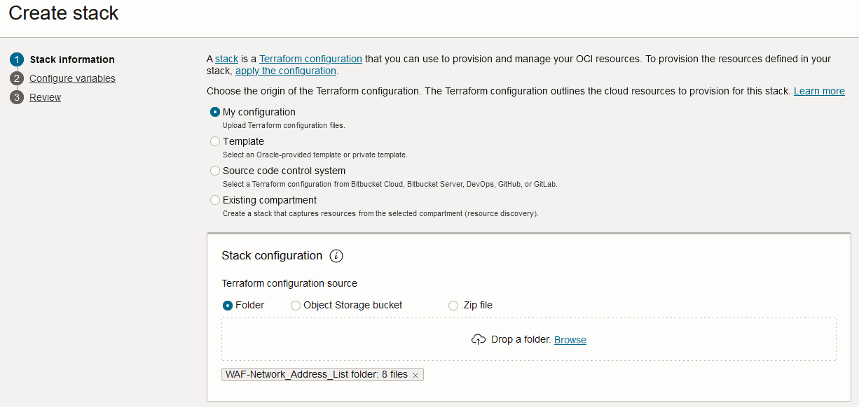

Select the parameters as per the below screen,
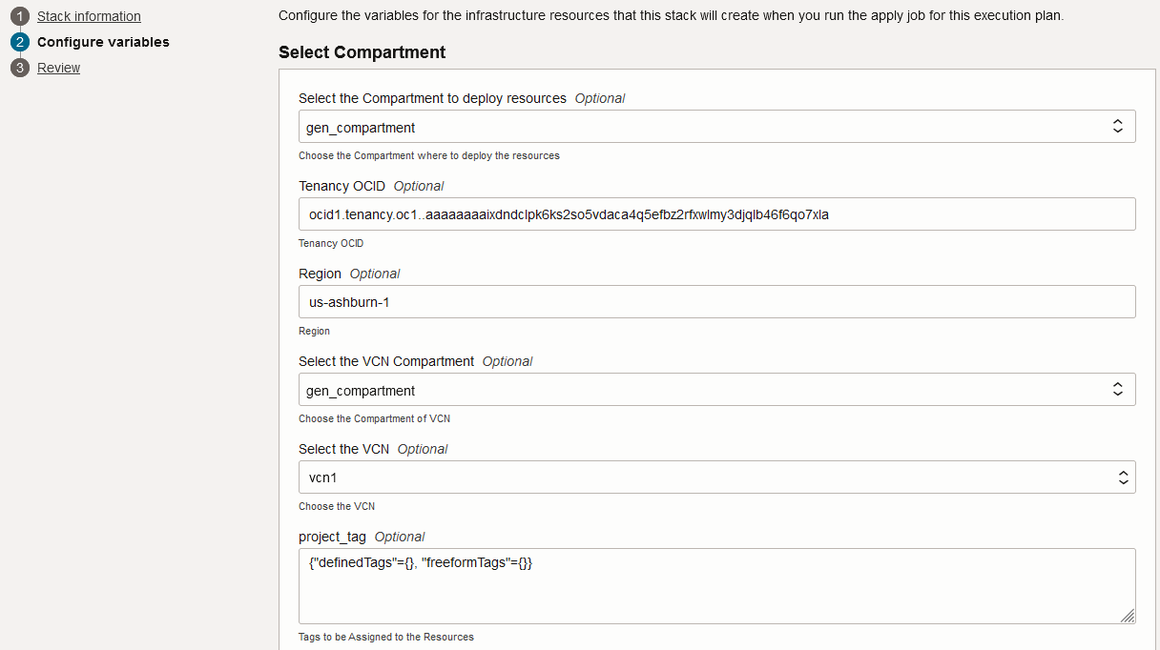
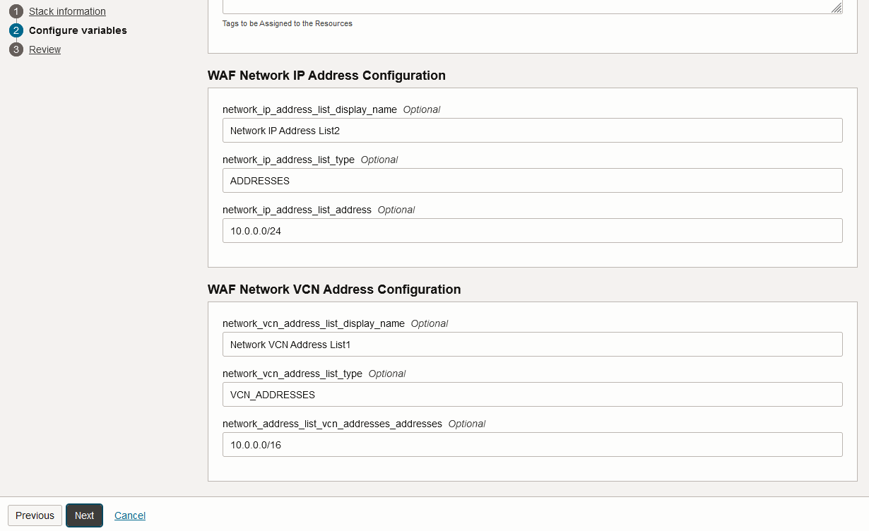
Click “NEXT”

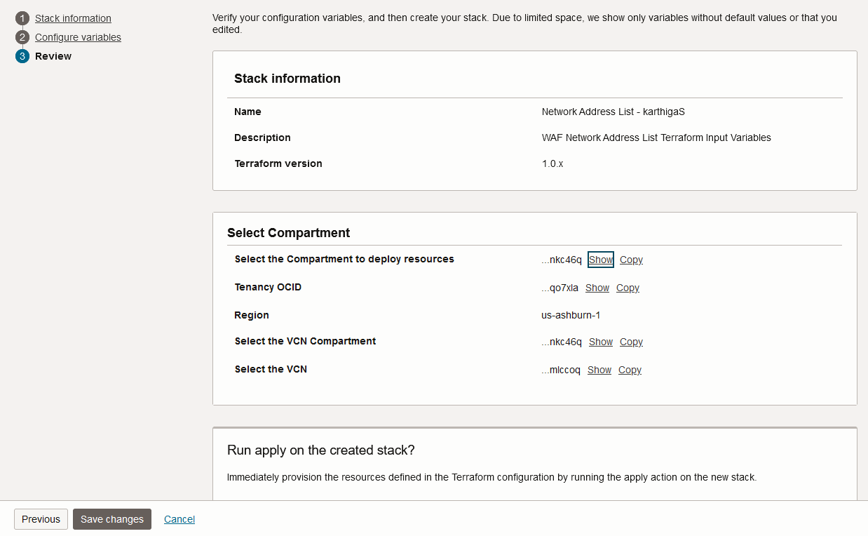
Click “Save Changes”

Plan the Job

Click the “Plan”

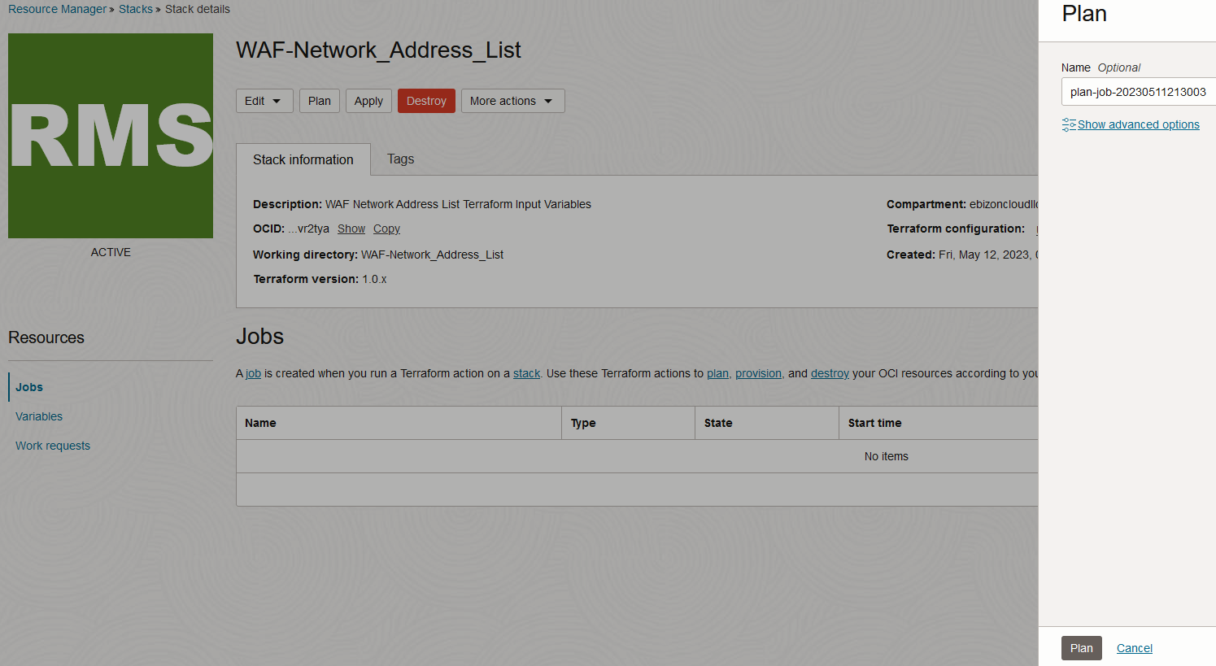

Verify the Plan is successful.

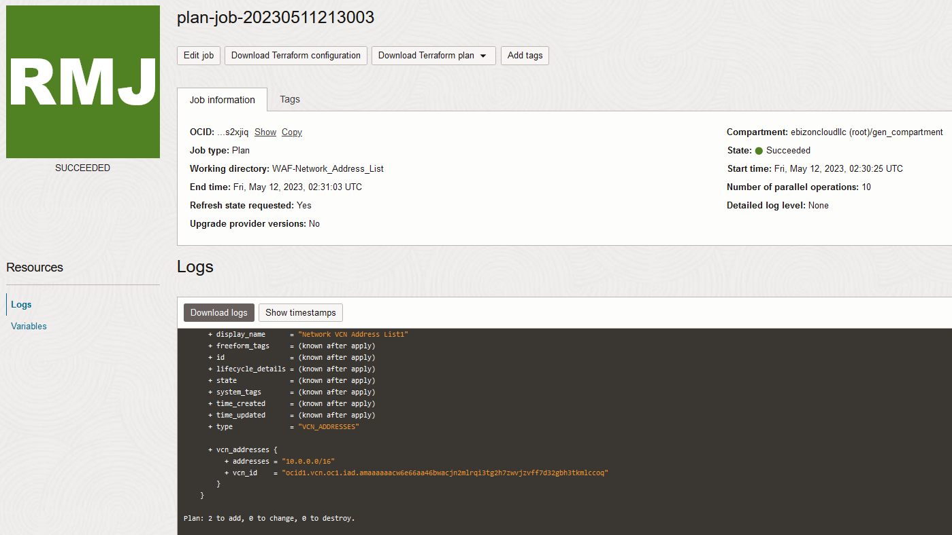

Apply the Job

Once the “plan” is success, now click “Apply”

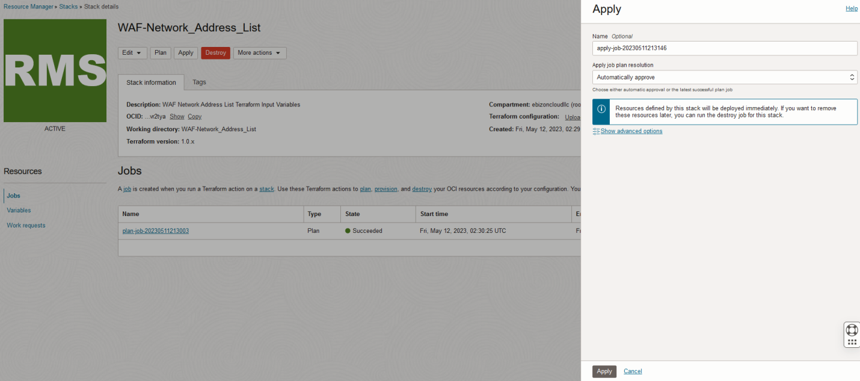

Verify the Apply is successful.

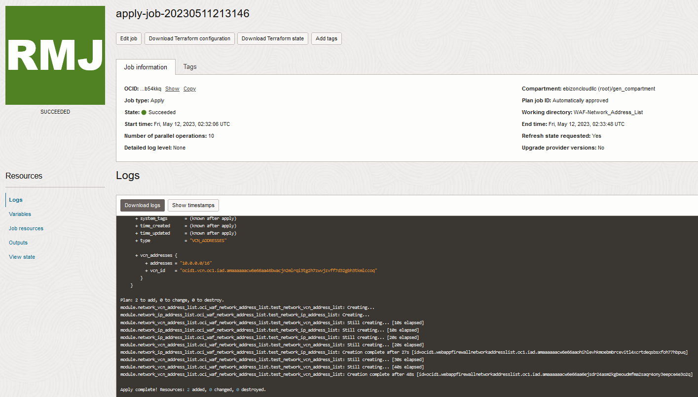

Verify in the Console

Go to OCI Console Web application firewall Network address lists

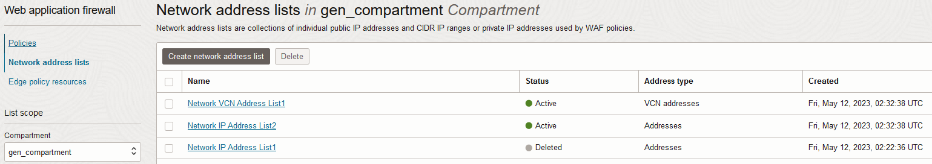

Web application firewall Network address lists Network address lists details

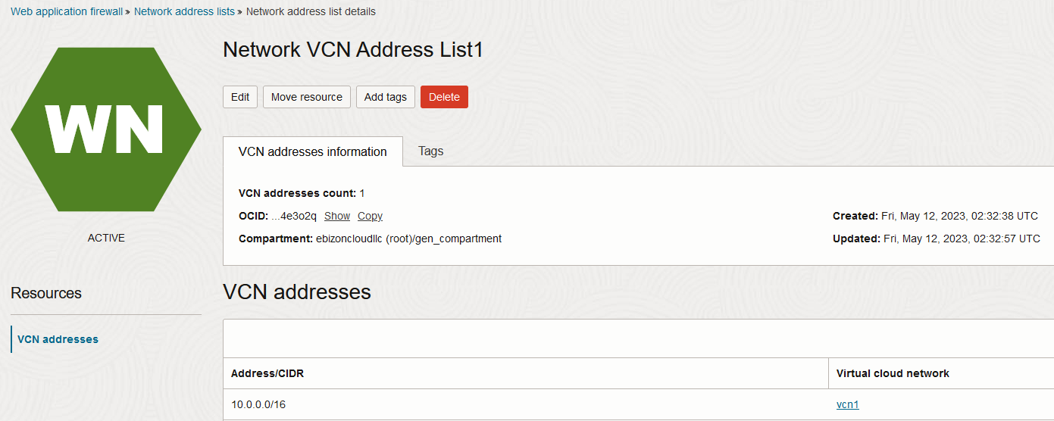
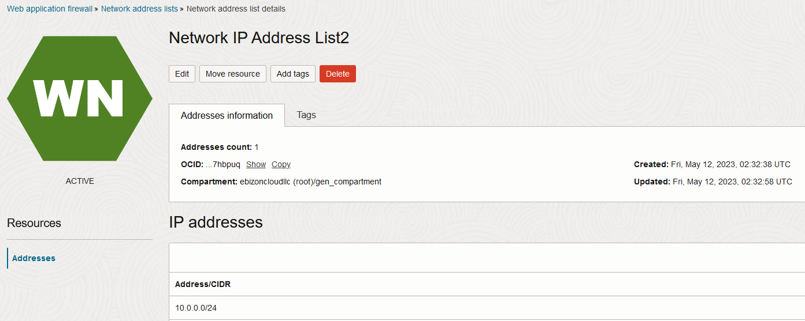

# END #

